Question 01:
Command:
Sudo adduser username
Output:
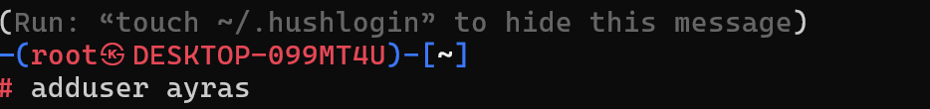
Question 02:
Command:
Passwd username
Output:
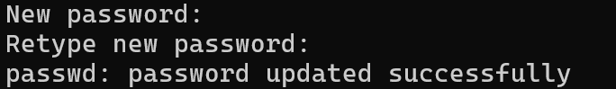

Question 03:
Command:
Top
Output:
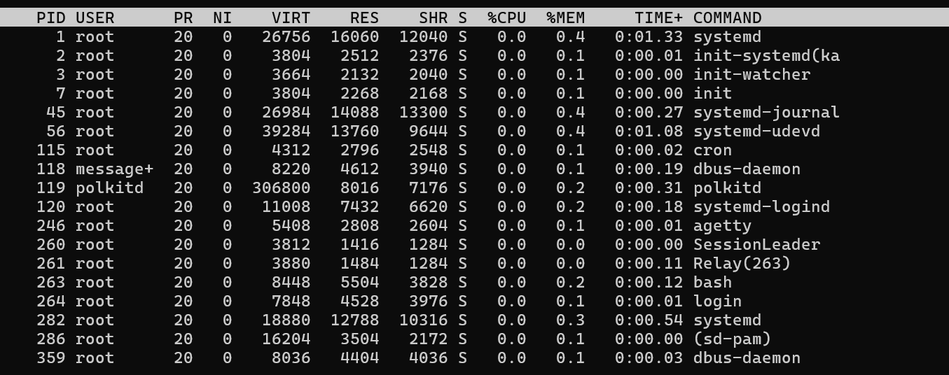
Question 04:
Command:
Kill PID-number
Output:

